**Cryptoverse Dashboard Documentation**

**1. Introduction**

**Project Title:** Cryptoverse Dashboard  
**Team Members:**

* **Team Leader:** Lokesh R – lokeshmt09.10@gmail.com
* **Team Member:** Barathan V – barathanv12b107@gmail.com
* **Team Member:** Kesavan P – kesavanp1309@gmail.com
* **Team Member:** Santhosh V – sv067031@gmail.com

**2. Project Overview**

**Purpose**

The Cryptoverse Dashboard is a React.js-based cryptocurrency tracking application that provides real-time market insights and historical data analysis. It is designed to help crypto enthusiasts monitor trends, analyze price movements, and make informed investment decisions.

**Features**

* Global cryptocurrency market statistics
* Searchable and paginated list of cryptocurrencies
* Detailed coin profiles with interactive zoomable charts
* Comparison tool for side-by-side price analysis
* Dark-themed UI with neon accents
* Powered by CoinGecko API, Redux Toolkit, and Chart.js

**3. Architecture**

**Component Structure**

* **Home.jsx** – Displays global market statistics and top 10 coins
* **CryptoList.jsx** – Lists cryptocurrencies with search and pagination
* **CryptoDetails.jsx** – Provides detailed views and price charts of specific coins
* **CryptoCompare.jsx** – Allows side-by-side comparison of two cryptocurrencies
* **Navbar.jsx** – Sidebar navigation with search functionality

**State Management**

The application uses **Redux Toolkit** for global state management. It stores:

* Global market data
* List of cryptocurrencies
* Detailed information of individual coins
* Historical price trends
* Selected coins for comparison

**Routing**

Implemented using **React Router**:

* / - Home
* /currencies - All Currencies List
* /currency/:id - Crypto Details Page
* /compare - Crypto Comparison Page

**4. Setup Instructions**

**Prerequisites**

* **Node.js & npm**: [Download](https://nodejs.org/en/download/)
* **Git**: [Download](https://git-scm.com/downloads)
* **Code Editor**: Visual Studio Code recommended ([Download](https://code.visualstudio.com/))

**Installation**

1. Clone the repository:

git clone **https://github.com/Im-Lokesh-R/Cryptoverse-A-Cryptocurrency-Dashboard-SWTID1741324641146409.git**

1. Navigate to the project folder:

cd cryptoverse-dashboard

1. Install dependencies:

npm install

1. Start the development server:

npm start

1. Open http://localhost:3000 in the browser.

**5.Folder Structure**

cryptoverse-dashboard/

├── public/

│ ├── index.html

│ ├── favicon.ico

│ ├── logo192.png

│ ├── logo512.png

│ ├── manifest.json

│ ├── robots.txt

├── src/

│ ├── components/

│ │ ├── Home.jsx

│ │ ├── CryptoList.jsx

│ │ ├── CryptoDetails.jsx

│ │ ├── CryptoCompare.jsx

│ │ ├── Navbar.jsx

│ ├── features/

│ │ ├── cryptoSlice.js

│ ├── App.js

│ ├── App.css

│ ├── index.js

│ ├── index.css

│ ├── store.js

│ ├── reportWebVitals.js

├── .gitignore

├── package.json

├── package-lock.json

├── README.md

**6. Running the Application**

* **Frontend Server:** Run npm start in the project directory.

**7. Component Documentation**

**Key Components**

**Home.jsx**

* Displays global cryptocurrency statistics.
* Lists top 10 performing coins.
* Fetches data using fetchCryptoData and fetchGlobalData.

**CryptoList.jsx**

* Shows a paginated list of cryptocurrencies.
* Includes search functionality.
* Fetches data using fetchCryptoData.

**CryptoDetails.jsx**

* Provides a detailed view of a selected cryptocurrency.
* Features an interactive price chart with time range selection.
* Displays key stats like price, market cap, and supply.

**CryptoCompare.jsx**

* Enables side-by-side comparison of two cryptocurrencies.
* Features a dual-line chart for historical price trends.
* Fetches data using fetchCryptoDetails and fetchCryptoHistory.

**Navbar.jsx**

* Sidebar navigation for smooth user experience.
* Includes a search bar for filtering cryptocurrencies.

**8. State Management**

**Global State**

* Managed using **Redux Toolkit**.
* Stores:
  + Global market statistics
  + List of cryptocurrencies
  + Individual coin details
  + Historical price trends
  + Selected coins for comparison

**Local State**

* Local component states are used for UI interactions, such as:
  + Handling search input in Navbar.jsx
  + Managing pagination state in CryptoList.jsx

**9. User Interface**

**Screenshots/Demo**

* [**Demo Link**](https://drive.google.com/file/d/1Ysy0K9Pe0rJXl-kuNCD0g3LIMNLFg21P/view?usp=drive_link)
* [**GitHub Repository**](https://github.com/Im-Lokesh-R/Cryptoverse-A-Cryptocurrency-Dashboard-SWTID1741324641146409)

**UI Features**

* **Home Page**: Displays global market stats and top 10 coins.

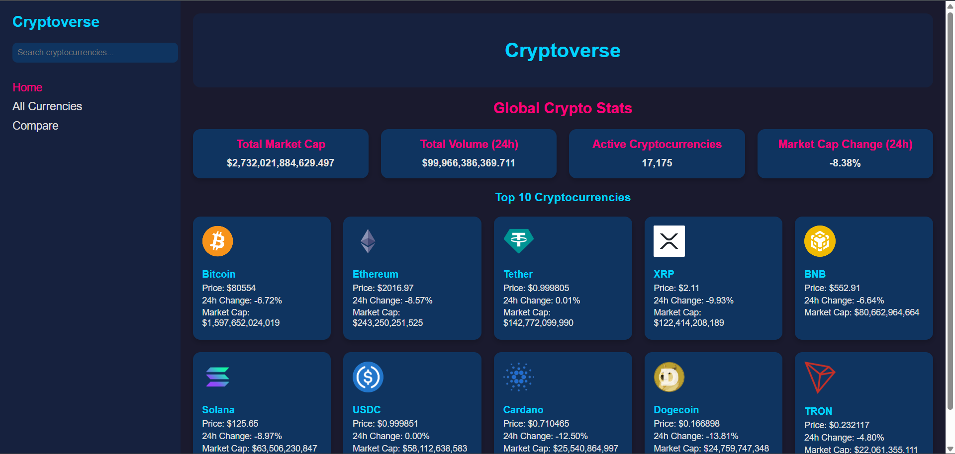

* **All Currencies Page**: Searchable and paginated list of cryptocurrencies.

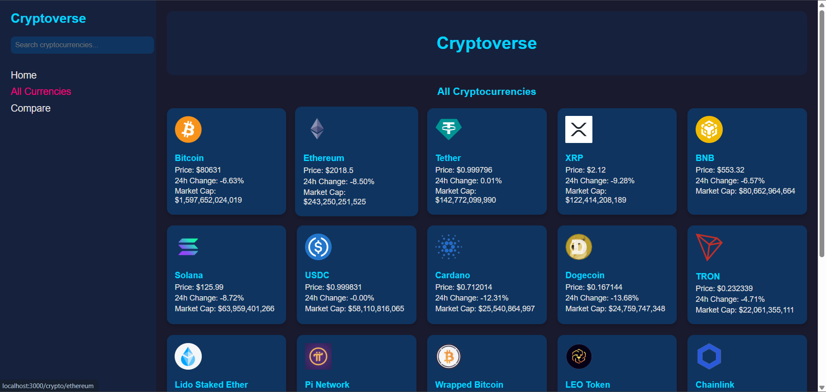

* **Crypto Details Page**: Individual coin information with interactive charts.

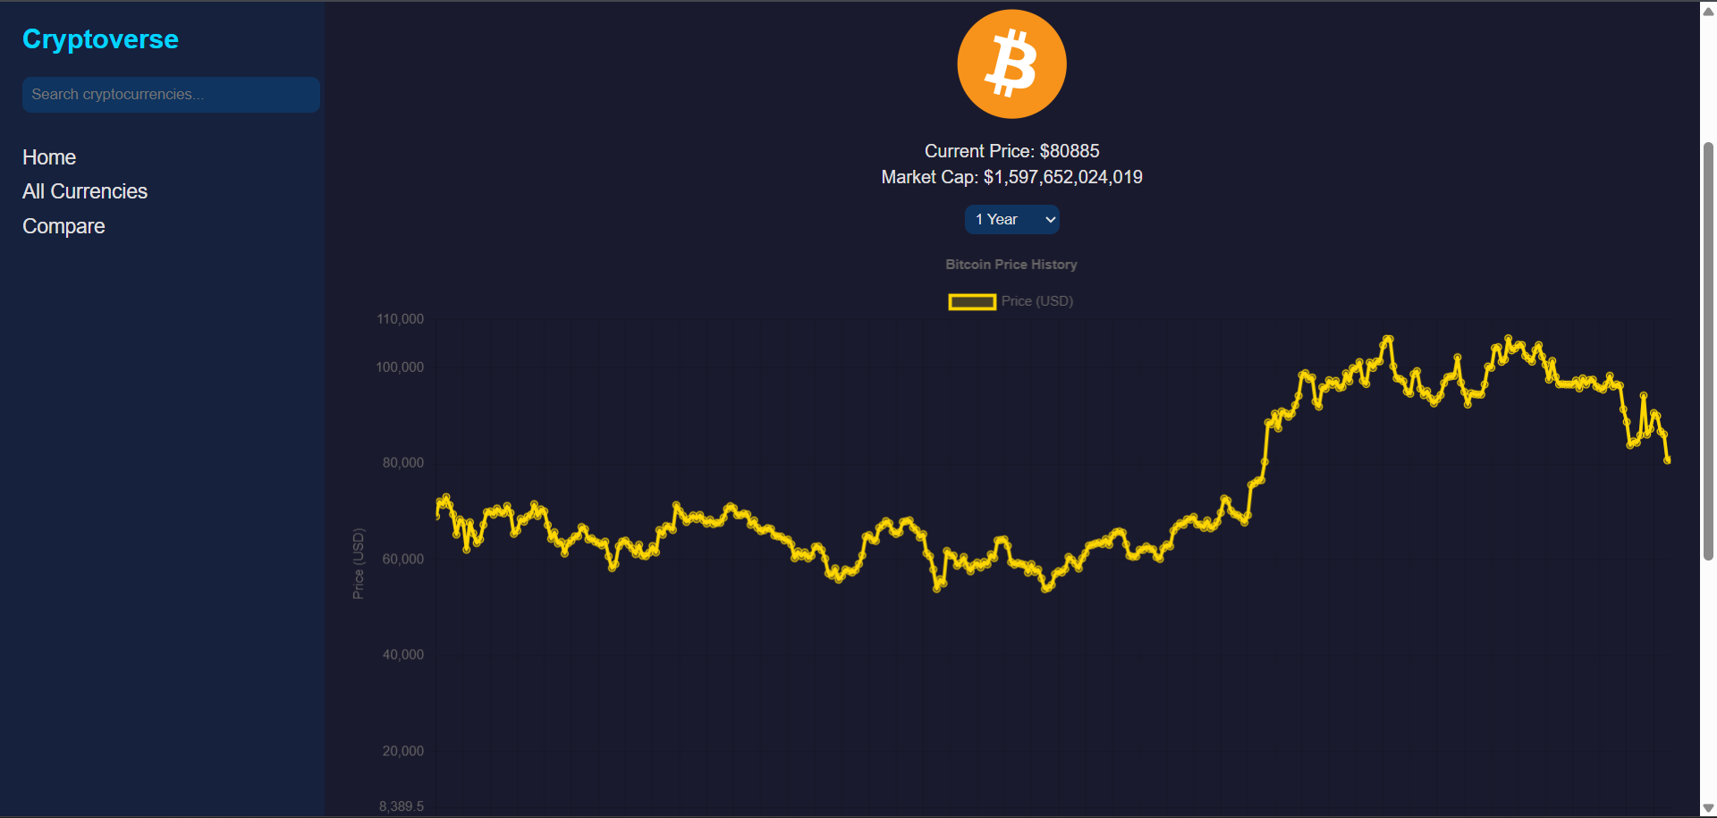

* **Compare Page**: Side-by-side comparison of two cryptocurrencies.

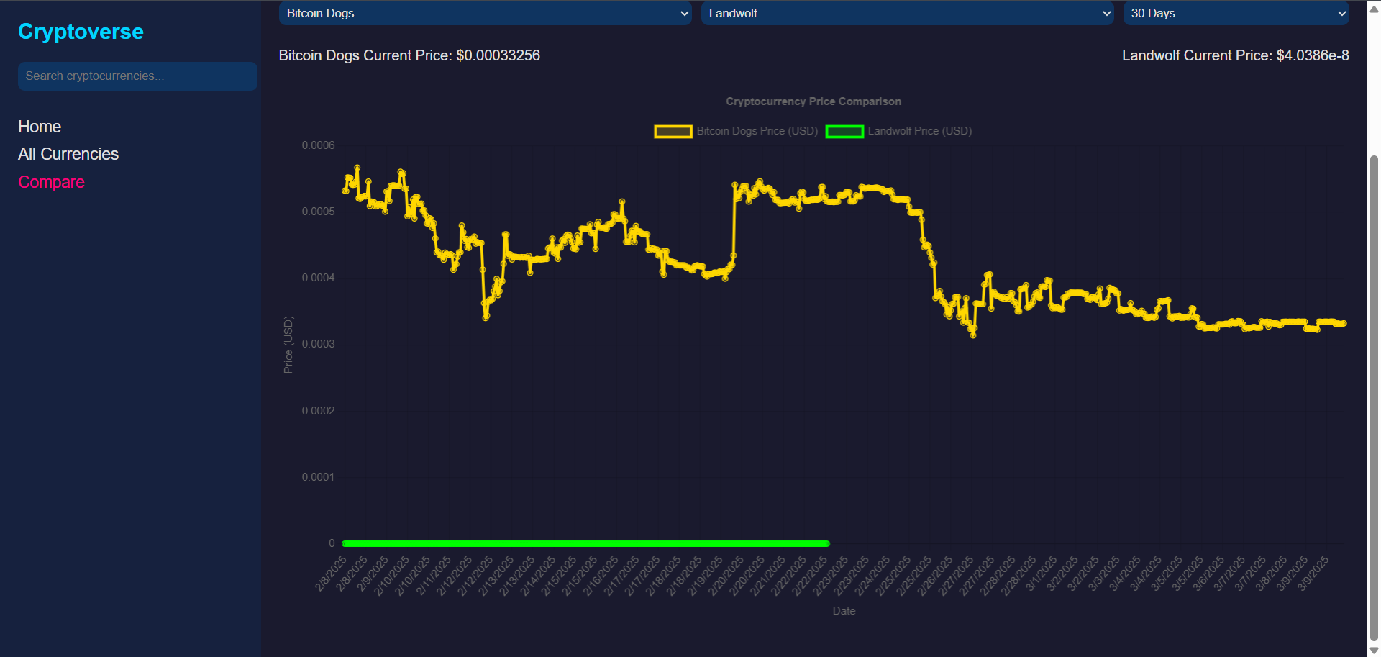

**10. Styling**

**CSS Frameworks/Libraries**

* Styled using **standard CSS** with a dark neon theme.

**Theming**

* Dark mode with **neon accents** for a futuristic look.
* **Grid-based layout** for better responsiveness.

**11. Testing**

**Testing Strategy**

* **Unit & Integration Testing** using @testing-library/react.
* Components tested include:
  + Navbar.jsx for search input behavior.
  + CryptoList.jsx for pagination and filtering.
  + CryptoCompare.jsx for comparison chart updates.

**11. Testing**

**Testing Strategy**

* **Unit & Integration Testing** using @testing-library/react.
* **Components tested include:** 
  + Navbar.jsx for search input behavior.
  + CryptoList.jsx for pagination and filtering.
  + CryptoCompare.jsx for comparison chart updates.

**Run Tests**

npm test

**12. Demo**

* **Demo Video**: [Watch Here](https://drive.google.com/file/d/1Ysy0K9Pe0rJXl-kuNCD0g3LIMNLFg21P/view?usp=drive_link)
* **GitHub Repo**: [Check Here](https://github.com/Im-Lokesh-R/Cryptoverse-A-Cryptocurrency-Dashboard-SWTID1741324641146409)

**13. Known Issues**

* **API Rate Limits**: The CoinGecko API has request limits that may restrict frequent updates.
* **Data Inconsistency**: Some coins may lack sufficient historical data for comparison.

**14. Future Enhancements**

* **User Authentication**: Allow users to log in and save favorite cryptocurrencies.
* **Portfolio Tracking**: Enable users to track their crypto holdings in real time.
* **Real-time Price Alerts**: Integrate WebSockets for instant updates.